UDL Tech Guidelines – March 20, 2007

This document contains technical guidelines for the UDL activity environment. It does not contain UI designs or graphic designs, but describes the architecture at a high level and discusses the user experience also.

Overarching Parameters:

Font size: All components need to allow for variations in font size. The UI will have to account for these variations.

Default font sizes:
- Grade 3-4: 14 point.
- Grade 5-8: 12 point

3 font sizes overall: 12,14 and 16 point. The user can increase their font size, but in the case of Grade 5-8 we do not allow them to lower their font size. This is a suggestion, but we could choose otherwise. If we want 5-8 to be able to go to 10 point, for example, the layout needs to be designed for 4 different font sizes.

We will need to choose the font (Arial?). It may be fine to allow variations for the main text font (Times, Arial, etc) but I doubt we want to get started on allowing fonts to change within components. The layout issues with this may quickly become a problem.

Since all components need to change, we also have limitations on what sizes we can support. Whenever possible, tools will use images to convey a function as opposed to words, but graphs need titles, and other components may need labels, etc. Tool tip sizes should change as well. We will try to minimize text within flash, but eventually we need the ability to change this text size also.

➲ We may run into problems with MW and / or NetLogo for changing font size. Needs to be looked at further. If control of model is brought out of the model to javascript, then at least we have a work-around. The student uses the larger size fonts in the javascript to control the simulation.

Coloration: skin color scheme. The overall environment needs to allow for different background colors and font colors.

The user will have control over several color options
- Font color
- Hyperlink color
- Background Color

The controls will need to be smart to some degree. For example, if the student chooses a font color of purple, the hyperlink color cannot be purple, nor can the background color. I don't think we get into restriction contrasts – font is purple, so hyperlink cannot be black – but we may want to discuss.

Language: localization options need to include text language changes and audio conversion to multiple languages. The environment needs to support this.

Are we dealing with text-to-speech conversion software, or spoken voice. Some commercial vendors, and others, prefer recorded spoken voice. I do as well, but as an exemplar, we may be able to get away with a software version.

Preference Panel

We will initially have two levels of preferences: Teacher defined and student defined. The software will initially default to some defined state. For example, grade 3-4 will have a font size of 14, sound will be on, the color scheme will be green text on a white background, etc.

Before deploying the software to the class, the teacher will be able to choose what she would like students to see, on a student-by-student basis. For example, the teacher generally does not want sound on, so she switches the whole class to sound off. But two students have a really difficult time reading, so she turns sound on for those two students. She then tells the software to hide the sound on/off control to all students, so in essence the sound controls are fixed based on student log-in. She decides all students can choose font size or color, so she leaves these controls available. She then sets learning preferences for some of the students:

Teacher Defined Parameters: As a method of setting up a course, the teacher will have the ability to define a number of things, including:
- Sound on/off available. The teacher will have the choice as to whether this parameter is available to the student. If the teacher does not want sound in the classroom, for example, she can choose to disable this aspect of the software.
- Sound on/off.
- Font size available
- Font size preference.
- Coloration changes available.
- Coloration preference.
- Language changes available.
- Language preference
- Guiding character available?
- Guiding character preference?
- Learning style settings. (ex. Multiple choice answer, essay answer, graphically-oriented answer, etc.)

➲ Need to look more closely at what these learning style preference are. They are discussed in more detail in the section below on the Question tool.

Student Defined Parameters: In any lesson, the student will have a preferences toolbox which will allow for UDL flexibility. Some of these may disabled based on what the teacher defined. Some of the items include:

- Sound on/off.
- Font size.
- Coloration preference. We may decide to have only "skins" available, or to have a more full level of control available. It may be based on grade level.
- Language preference
- Choose a guiding character?

Specific Tools

Question Tool.

The question tool will display a question and an answering mechanism based on a numeric scaffold input of 1-5 (or 1-x). The Question tool will allow the author to write x number of variations of the question, for example:

Var 1:
Here are some examples that suggest there is water in the air:

- Clothes will dry when you hang them out in the air.
- Rain comes out of the sky.
- When you boil water, it gradually disappears. Perhaps it goes into the air.
- Water drops appear on the surface of cold things. Perhaps the water comes out of the air.
- On some days the air feels damp.

Give two more examples.

Answer Type: Text Entry

Var 2:
Pick the best answer, and explain:

1. There is no evidence that there is water in the air.
2. There is water in the air because there is water in everything.
3. There is water in the air because clouds are made of water and they form in the air.
4. There is water in the air because clouds hide the sun.

Answer Type: Multiple choice with text entry.

Var 3:
Pick three answers and fill in the missing idea.

1. Clouds show that there is water in the air because ____________________.
2. Rain shows that there is water in the air because ____________________.
3. If there were no water in the air, there would never be ____________________.
4. When you boil water, it gradually disappears. This shows there is water in the air because ____________________.
5. Clothes will dry when you hang them out in the air. This shows there is water in the air because ____________________.
6. Water drops appear on the surface of cold things. This shows there is water in the air because ____________________.

Answer Type: Fill in the blank.

Var 4:

When scientists ask "why" questions, they are looking for evidence. Think of two examples. Explain how they suggest that there is water in the air.

Answer Type: Text Entry

Var 5:

Which of the following pictures shows water? Check all that apply.
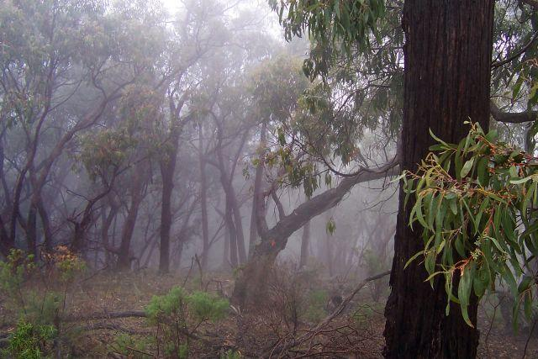

Var 6:
Which of the following picture shows horses. (Radio Button)

➲ The current thinking on how questions will be handled is as follows: Question types will have tags i.e. open-ended, graphical, guiding, highly guiding, etc. There may be more than one type of answer that would be graphical, guiding, open-ended, etc. For a given activity, the author will define several paths: general path, graphically oriented, open ended, guided. The teacher can then set a parameter for each student, as to how they think the student should go through the activity.

For example, the teacher would see an interface that would allow the student Learning Style Preferences.

Name | General Path | Graphic | Open-ended | Guided
Student 1 | X
Student 2 |  | X
Student 3 |  | X
Etc.. |  |  |  | X

"General Path" above would be the authors recommendation on an approach that contained different styles of questions based on the situation, much like the current TEEMSS model.

Note that the activity still has to have a natural feel to it. By choosing the "Graphic" assessment variety, the student will see predominantly graphic assessments, but may still see other types of questions where appropriate.

The control panel depicted above would be in the Teacher Preferences window, where she could be setting sound, font, color preferences as well. For the teacher who did not want to be inundated with variables, the General Path option above would be the default.

Molecular Workbench.

Molecular Workbench can be imbedded within the environment. Will we have any control over color schemes or text labeling within MW?

Flash Zoom.

Flash zoom will be enabled through 2 different swfs. The controlling swf will give an overall context (macroscopic) and provide zooming hotspots. For example. The macroscopic image could be:

Through calls from the environment text, a zooming swf could be called that would zoom in on the cloud, or zoom in on the blue sky. The zoom will take place in the same real estate as the original flash. Once fully zoomed in, the flash can call a drawing tool or MW for further functionality in the same workspace (real estate).

Labeling on flash – for localization purposes, labeling will need to be done with dynamic text or a transparent graphic layer. Have to look at Flash abilities for font size changing – either could be done with a layering or with some action script to change font size.

Guiding Character.
Two or more guiding characters that can "speak" when words are spoken. These would likely need to be time-synced to the spoken text, or else we need some simple animation that implies that the character is speaking or at least present, while not being as complex as an actual speaking animation. Even if sound was off, a guiding character could be present as someone to go through the activity with.

➲ The thinking is that the UDL model would be one person working on a computer. The guiding character can be "someone" that the student goes through the activity with. It probably becomes less compelling if multiple students are working together on a single computer. However, if this is the case, many of the UDL features will be challenging to implement.

Input Options

Slider. Vertical or horizontal slider than can define a variable for a flash file or for MW(?) or any other component within the environment.

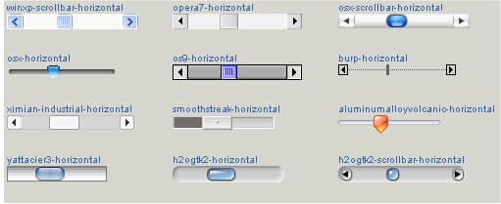

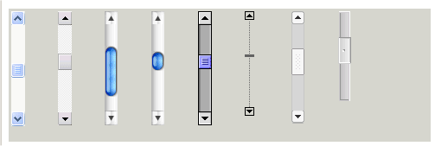

Buttons

Allow for an invisible button or a button that can load a graphic file, roll-over and click image. Button should be able to pass variable to flash, MW, etc.



Smart Grapher

auto-resize, so you can find your way home

rescale axis – numbers change color or go bold when you're in the right screen area to change them.

Explanation of the jump iin change of scale by factors of 1000.

Translate graph (with hand)

Label a data point

General text comment (can be put anywhere)

Name the graph (perhaps it should be required, because it's so easy to confuse graphs when you make several in a row).

Describe the graph (an accompanying textbox, rather than text on the graph) – again, forces one to describe the context of the measurement.

Draw a dataset (prediction, but also after the fact)

Zoom in to a selected area

Read a dataset value – crosshair line to X and Y axes (reinforces meaning of Cartesian plane)

Highlight a portion of the graph, and label it. (the line changes color, bolder, etc..)

Analysis (keep this limited, for primary grades): maximum and minimum, slope (of a highlighted segment for instance), time between two measurements, difference of two measurements, average y-value of a segment.

Save, go back to it and continue to analyze and add comments.

Need to think more about what in inexperienced student doesn't understand about a graph. Will the abovementioned tools help them, as well as being useful to someone who already understands graphs?

Live Polling

Drawing Tool

Report writer

