Plant 3-4 Activity 2
Picture Descriptions

I have gone through Confluence and labeled all the pictures 1 – 32. I did this because I understand that some of the plant activities have already been converted.

Below is a list of directions of what pictures to keep and what pictures to toss. And then detailed directions on what the pictures should contain.

The goal of pictures 1 – 3 is to show all the kinds of parts of a plant. (ex. Roots can be tap root or fibrous, leaves can be large like palm leaves or thin like pine needles, stems can be thick like tree trunks or thin. These pictures will be repeated through out the rest of the lesson. All the pictures need to show both above and below ground views.
The clip art that is the place holder are examples of the variation needed in the pictures

All of the pictures below except for the last one can be in color. The last one needs to be in Black and White.
---------------------------------------------------------------------------------------------------------

#1 Potato
Cynthia - Trashing original picture in this spot and what is on Confluence. Moving #13 to this spot instead – the clip art of the potato.
Things it needs for learning – a thick root structure (the potato) and the green leaves, their does not need to be a long stem, the leaves and stem can be one thing.
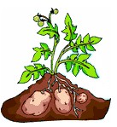

#2 Prairie Grass -
Things it needs for learning – long thin stem, long thin root, sparse leaves that are present but not in your face. Need to be able to see the leaves but don’t need to be like oak leaves.
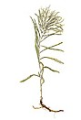
#3 Large Tree that has a very complex root system below, leaves need to be large and bushy. The current clip art picture does not really show the leaves, please make the leaves a little more defined.
Things it needs for learning – the thick trunk, large green leaves, and complex root system.
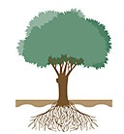

#4 Cutting a Leaf off a plant
The goal of the picture is to show where students need to cut their leaves. The person in this picture is cutting a leaf off of a stem at the section where the stem of the leaf connects with the stem of the plant. The example picture does not show this but the cartoon picture will need to be really explicit about where the scissors are cutting. The plant in the picture needs to have large leaves with long leaf stems.

#5 Stomata of the leaf – picture taken from TEEMS – waiting for access to TEEMS website.

#6 Dropping

#7 Dropping

#8 De-Leafing the Stem
Show all the leaves carefully pulled off of the stem. Basically draw the picture given.

#9 Dropping
#10 Dropping
#11 Dropping
#12 Dropping
#13 Dropping
#14 Dropping
#15 Dropping
#16 Dropping
#17 Dropping
#18 Getting to the roots of the plant
Show the leaves roots and a little bit of soil left on the roots. The students will need to pull apart the plant and clean the roots. Basically draw the picture – I don’t think you need the hand and figures in this picture.

#19 Dropping
#20 dropping
#21 dropping
#22 Cleaning the roots
Draw the picture as it stands. The person is swishing around the plant in the cup of water to remove the soil.
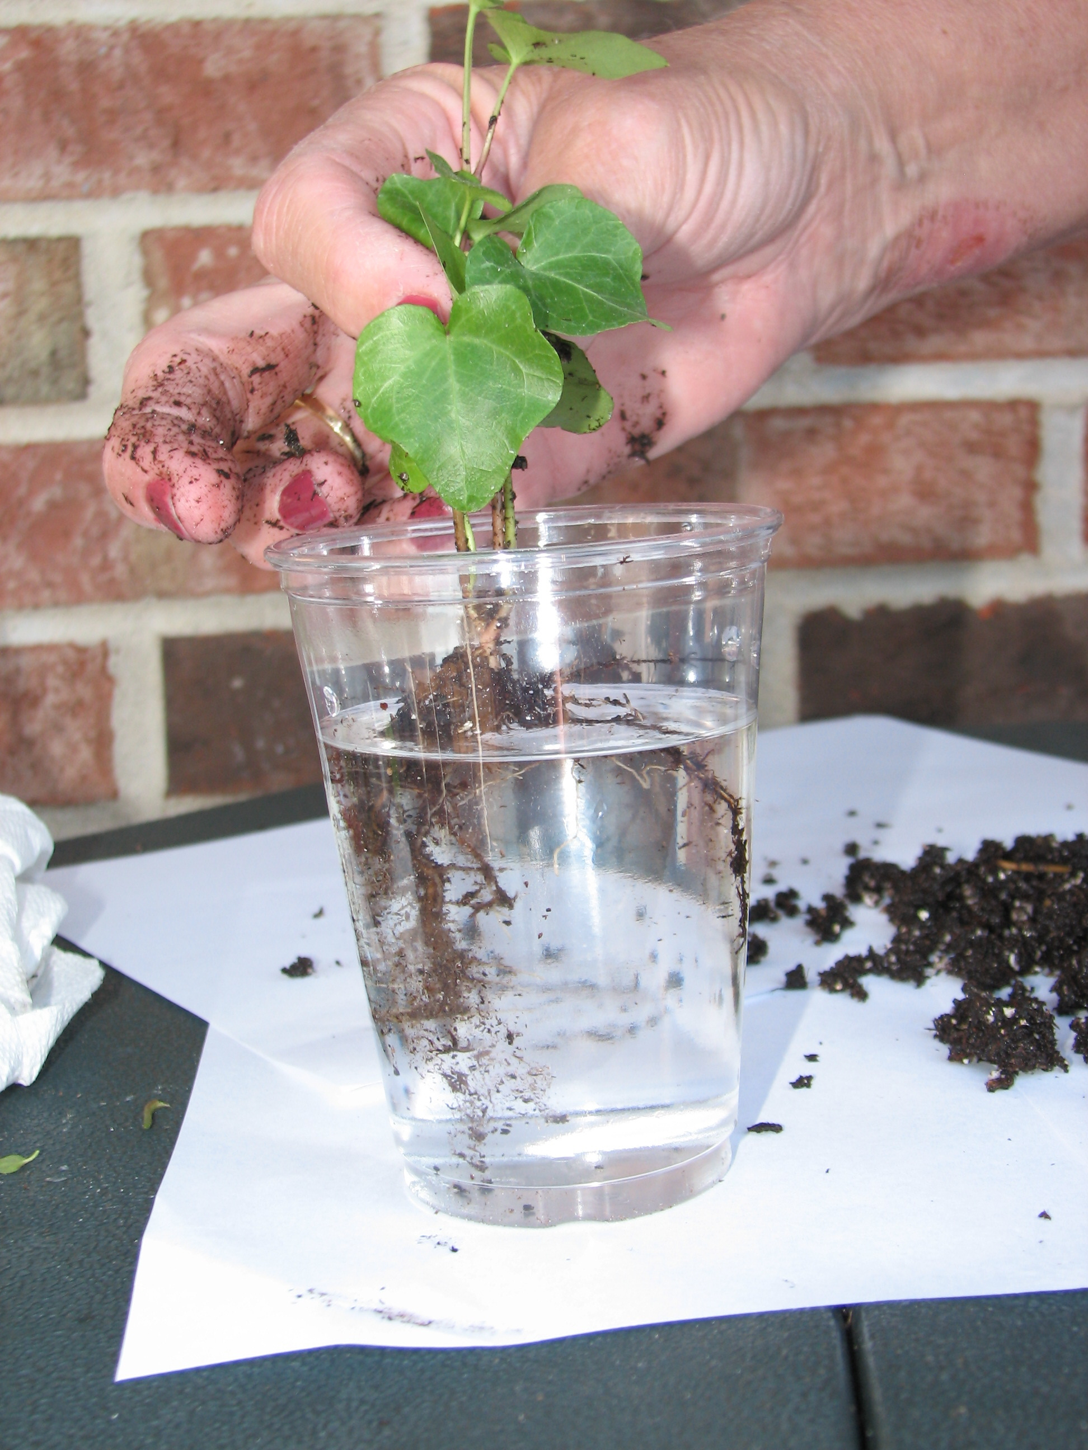

#23 dropping but showing #2 instead
#24 dropping
#25 dropping
#26 dropping
#27 dropping but showing #3 instead
#28 dropping
#29 dropping
#30 dropping

All of these pictures are the same picture just used in multiple locations.
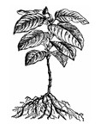
#31
#32
#33
#34

Directions for the picture - Need the picture as it stands, The roots and leaves can be more defined and obvious. It also needs to be in black and white.

