MBL Software Overview

This document looks at the software applications provided by the following list of vendors:

- Coach
- Data Harvest
- Fourier
- Imagiworks
- Onset
- Pasco
- Vernier
- TI

Each piece of software is briefly reviewed, to give an overview of the features and capabilities of each system.

Coach 5 version 0.89
Centre for Microcomputer Applications
Kruislaan 404
1098 SM Amsterdam
The Netherlands

Phone: +31 20 5255866
Telefax: +31 20 5255866

E-mail: cmainternational@science.uva.nl

The Coach software supports a variety of different interface boxes, including a proprietary set of CoachLab equipment. The list is as follows:
- CMA's CoachLab I and CoachLab II; UIA and UIB boards;
- Texas Instruments' CBL™, CBL2™ and CBR™;
- Vernier's LabPro™;
- Fourier Systems' EcoLog™;
- LEGO DACTA®'s Control Interface and RCX™.
This looks to be a robust piece of software, that supports a lot of different abilities. Much of what it can do will not be needed in K-8 applications, however the flexibility should make a it an easy to use piece of software for the project. Some of key features are:
Measuring (input): Yes
Control (output): Yes
Programmable: Yes - robust
Triggering: Yes
List of Display Types: Table, Line Graph
Built in Table/Spreadsheet: Yes
Diagraming (drawing tool): Yes
Analog and Digital probes: Yes
Calibration: Automatic or manual
Save a lab: Yes

A drawback seems to be the display types. In a first look at the software, I could not find bar charts or any other representation other than a table and a line graph (no pie charts as well.)

Two views of the Coach software are shown below.
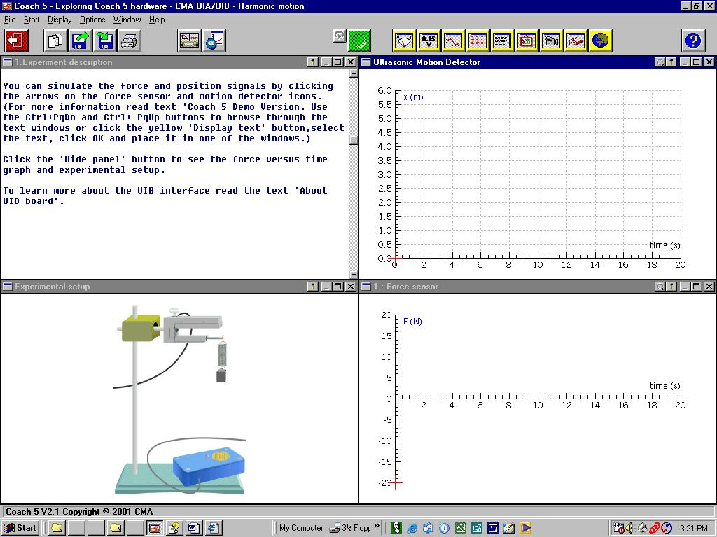

Figure 1. Shows an experimental set-up with a two types of line graph displays. In addition, there is space for instructional text.

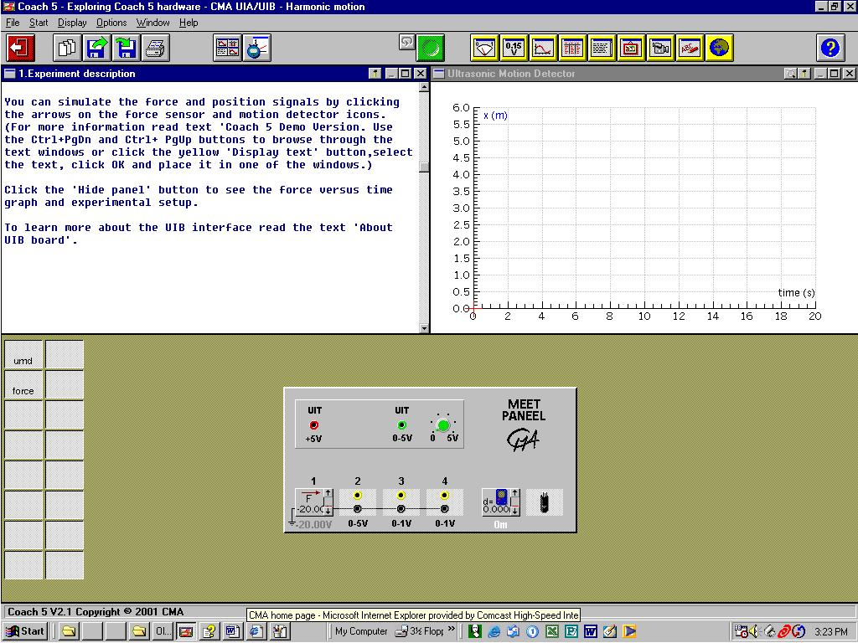

Figure 2. Hides the experimental set-up and shows the interface box connections (which probes are connected to which ports.)

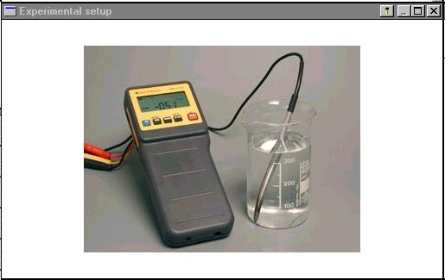
Figure 3. The Coach system also has the ability to show photographs in it – a clear way to show an experimental set-up.

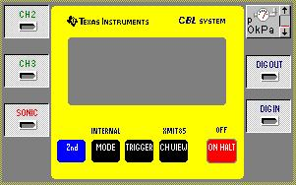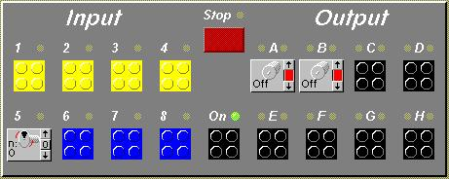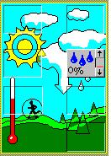

Figure 4. Different Interactive images of the probe boxes, depending upon which probes are being used.

Summary:

The Coach system seems to be a high level piece of software with a lot of flexibility to customize. It has the ability to load a set experiment and with the touch of a button or two, gather a data set according to what is needed. It does not appear to have too much flexibility in data representation – only a table and a line graph.

CPO Science
26 Howley St.
Peabody, MA 01960
Tom Hsu

I found several experimental set-up pieces of equipment and some photogates, but I did not find an MBL or interface software. Did I miss something?

Data Harvest
Data Harvest International
Box 628
Buffalo, NY 14213
craig@dataharvest.com
Steve Whitley

Data Harvest has several hardware offerings, which utilize particular software. I suggest that we have them recommend a system to use, and work with it. However, I’ve included a brief overview of the software for each system below. I could not find downloadable versions on the website, so these descriptions are based on what was available for review on the web site.

Sensing Science Laboratory Software for Pocket PC. ($159 for logger and software)

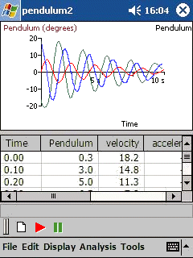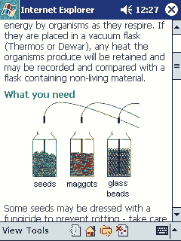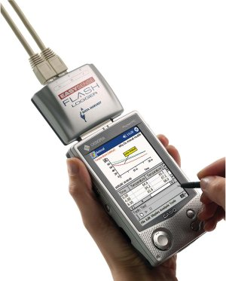

Figure 5. The above screen shots are from a Pocket PC running the free software that comes with the Flash Logger (shown to the right).

As stated on the website:

- Students can quickly and easily setup EasySense Flash to record data.  - Recorded measurements can be displayed and analyzed in graphs, charts and tables.  - Data sets can be saved, printed, exported to Pocket Excel or uploaded to a desktop computer. | - Lesson plans are Linked to data analysis software.  - Recording time-spans and display options are automatically configured.  - Several free sample lessons are provided with additional lessons available for purchase.
Summary: This pocket PC data collection system appears to have the ability to be pre-configured for a particular experiment. It can operate up to three sensors simultaneously, although I could find no examples of how this data would be displayed – would it be real time for all three sensors (I would think there would be a space limitation on the Pocket PC) or does it go into a table where it is then represented. The features do describe the ability to display multiple representations: table, bars, dials, numeric display or a “variety of chart types.”

Easy Sense Advanced Data Logger ($349 including software)

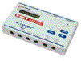
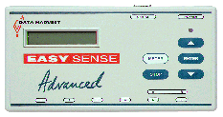
Figure 6. Front View of the Easy Sense Advanced Data Logger, and 3D view.

The Easy Sense Advanced Data Logger can take up to 6 probes simultaneously. The software for the Easy Sense is broken into 4 different packages.

1. Graph. The main program for plotting, tabling and analyzing sensor measurements
2. Timer. A specialized application for timing, velocity and acceleration investigations
3. Meter. An extremely simple application designed for younger students
4. Workroom. The ultimate helper: links on-screen experimental worksheets directly to Graph.

Further Description:

Graph - Graph is Sensing Science Laboratory's premier application. The program is very intuitively designed and is loaded with many analysis and data capture options. To enhance its usability, Graph provides numerous on-screen wizards that provide step-by-step instructions which greatly simplify the various setup and analysis procedures. The list below outlines some of the many features of Graph.
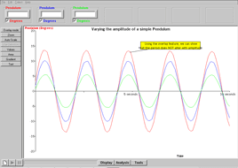
- View data in a graph or table
- Use up to six sensors to simultaneously record and plot data
- Overlay newly captured data on top of previously capture sensor plots
- Setup the Easysense loggers for either remote or real time data recordings
- Cut and paste data to popular spreadsheet and word-processing programs
- Display sensor plots as either a line or data plots
Figure 7. Screen shot of Graph
- Use many helpful Wizards for setup and analysis
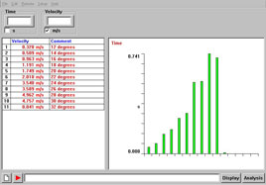
- Manually create data sets with the snapshot feature
- Annotate and title graphs
- Draw predictions directly on graphs prior to displaying plots

Timer - Timer is a specialized application for investigations into timing and motion. The program works exclusively with the digital range of SmartQ sensors such as Light Gates and Timing Mats. On-screen Wizards quickly enable the student to convert timing data into velocities and accelerations.
Figure 8. Screen shot of Timer
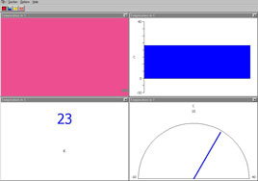

Meter - Meter is an ideal application for younger pupils and those seeking a simple introduction into using computers for capturing and displaying sensor readings. Readings can be displayed in formats that will be familiar to most students such as a number, gauge, dial or even a color.
Figure 9. Screen shot of Meter

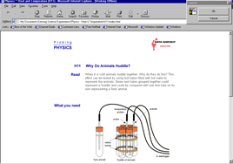
Workroom – Workroom is a piece of software where a set-up can be pictured, and configurations for probes can be automatically set. Workroom can launch Graph with the touch of a button to start graphing data in a preset set-up. One can design their own activities within Workroom, or buy activities already assembled by Data Harvest.
Figure 10. Screen shot of Workroom

Summary: The Easy Sense Advanced Data Logger is Data Harvest’s most powerful MBL configuration. It appears to support multiple representations, and can be pre-configured to open a lab that has appropriate sensors for an experiment. A possible downside is that to do much with it will require launching 2 pieces of software, on top of whatever piece of software we are using for the project. It may be relatively seamless – I would have to have some of the software to evaluate.

Ecolog ($299)
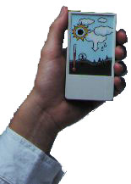
The Ecolog is spefically designed for both elementary and middle school, unlike the other two offerings from Data Harvest, which are middle school and up. The Ecolog has 5 built-in sensors for light, temperature, sound, humidity and pressure. It also has 2 ports for plugging in different sensors – the Ecolog can sense up to seven sensors simultaneously. It is battery operated, but it is not clear from the description whether or not it can interface with a computer in real time, or whether the data needs to be sampled and then exported to a computer for analysis with the software. While the description of the software is limited, it appears to be able to graph data in a variety of representations, and have the ability to set-up the Ecolog in a few “simple” steps. No screen displays of the software are available on the Data Harvest site.

Fourier

Two pieces of software are reviewed: MultiLab 1.3 and Imagiprobe 3.0. Imagiprobe software runs with the Fourier System, but is reviewed in the Imagiworks section following the Fourier section.

MultiLab 1.3
Multilab is a full featured software package that allows for many components of MBL operation. A Workbook tool can give directions to the student on how to run an experiment. Experiments can be saved as separate files, so that upon launch the Multilab software is configured to run a particular experiment.
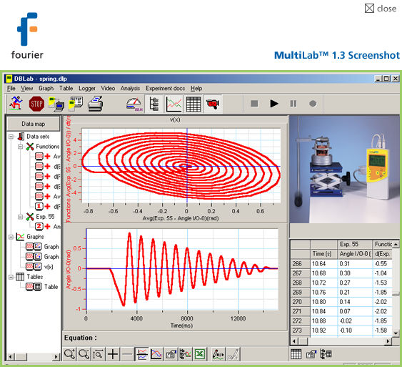
Measuring (input): Yes
Control (output): No?
Programmable: No?
Triggering: ?
List of Display Types: Table, Line Graph, Meters
Built in Table/Spreadsheet: Yes
Diagramming (drawing tool): Yes
Analog and Digital probes: Yes
Calibration: Automatic or manual
Save a lab: Yes
Analysis: Curve fitting and other data analysis tools.
Multimedia: Can show videos and play soundclips.
Export: Easy data export to Excel.

Figure 11. Multilab screen shot showing experimental set-up photo, table, 2 graphs.

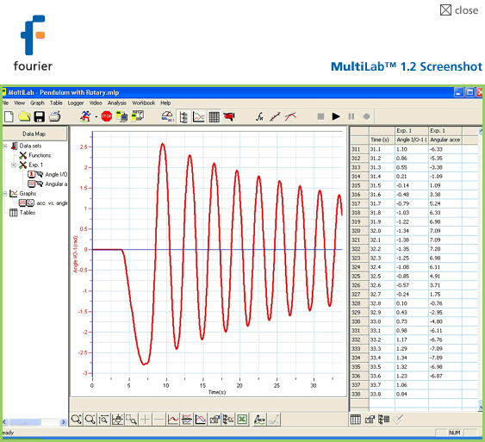

Figure 12. Another view of the Multilog software shows some of the tools available. It is not clear from the web site whether or not some of the tools can be hidden.

Summary: The Multilog looks to be a full-features piece of software, capable of running on Mac or Windows. Experiments can be saved, set-ups can be described within the software, and a variety of output types are available. Like the Coach system, it appears to have plenty of capability. It will likely more be a case of trying to hide some of the capability so not to confuse students in the lower grade levels.

Imagiworks

The Imagiworks system utilizes a Palm compatible handheld, and a PC – either Mac or Windows. In collecting data with the Imagiworks system, the student uses the Palm with an attached interface and set of probes to collect data. The data can be viewed and manipulated to a small extent, directly on the handheld. Further analysis takes place by downloading data from the Palm to a PC, in spreadsheet form. These text files can then be opened with Excel or other spreadsheets for analysis. Imagiworks software and probe system is called Imagiprobe.

Imagiprobe 3.0
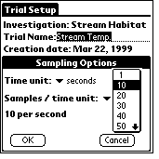
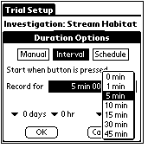
The Imagiprobe software has the advantage of being very portable on a Palm OS handheld, and the disadvantage of being more limited in what can be viewed or analyzed at any given time.

Figure 13. Screen shots of the Imaiprobe 3.0 software
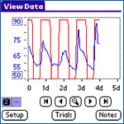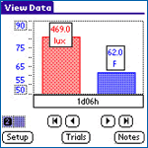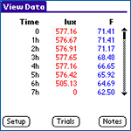
Figure 14. Above are 3 different display options for the data on the Imagiprobe system (Line, Bar, Table).
Measuring (input): Yes
Control (output): No
Programmable: No
Triggering: No
List of Display Types: Table, Line Graph, Bar Chart
Built in Table/Spreadsheet: Yes (table)
Diagramming (drawing tool): Yes
Analog and Digital probes: Yes
Calibration: Automatic or manual
Save a lab: Yes
Analysis: None
Multimedia: None
Export: Easy data export to Excel.
Summary: Because of its handheld nature, the displays for the Imagiprobe software are more limited than many of the other packages. It does have the ability to save an experiment set-up (referred to as an Installable Content Database). This content can be downloaded to each handheld from a PC or beamed from handheld to handheld. It is difficult within this software to show the experimental set-up, and how the physical experiment should be configured and conducted (from what I can tell, and from using previous versions of the software.)

Onset
Onset manufactures battery powered data collection devices, for a variety of applications. Most of Onset’s business appears to be in industrial application, although they do sell to the educational market. There appear to be 3 pieces of software available for Onset probes: HOBOware (Mac software for the HOBO U12 data-logger), Greenline (Windows software for the HOBO U12 data-logger), and HandCar Ex (a Palm platform piece of software.)

HOBOware
The HOBOware software is relatively basic in ability, designed for table or line graph output from a one or multiple probes. It does have the ability to export to Excel for further analysis. It’s appearance is not particularly friendly for lower grade level users.

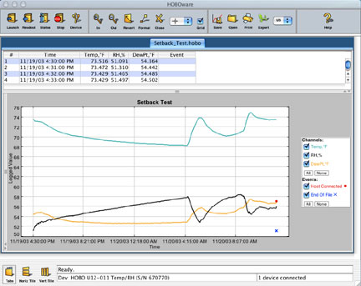
Measuring (input): Yes
Control (output): No
Programmable: No
Triggering: No
List of Display Types: Table, Line Graph
Built in Table/Spreadsheet: Yes (table)
Diagramming (drawing tool): No
Analog and Digital probes: No
Calibration: Automatic or manual
Save a lab: Yes
Analysis: None?
Multimedia: None
Export: export to Excel.

Figure 15. Screenshot of HOBOware for Macintosh showing a line graph and a table.

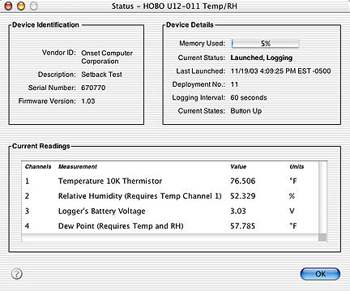
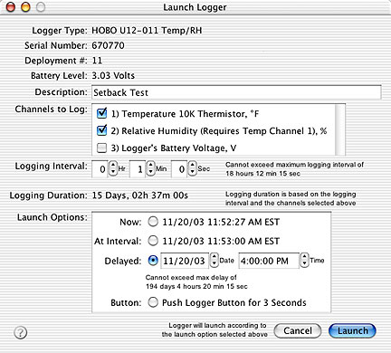
Figure 16. Two configuration views of HOBOware.

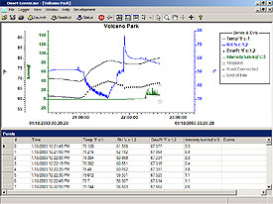
Greenline
This software seems to be similar to HOBOware, but made for Windows. It does not, however, seem to have the same set of operational tools as HOBOware, and it is unclear whether it will run a lab created for HOBOware, or whether it would need to be treated as a separate piece of software altogether.

According to the description on the web, the feature set seems to be the same as HOBOware.

Figure 17. Screen shot of Greenline

HandCar EX
This software allows a Palm OS device to operate Onset probes. It does not appear to be worth reviewing, since it does not allow any type of realtime display (as far as I can tell.) It appears to be for uploading data to a PC.

Pasco

DataStudio is one of Pasco’s MBL software packages. It has 2 main versions – a lite version that is available free of charge, and can collect data from a single probe, and the full featured version. I downloaded the lite version, but can extrapolate the features from the full version.

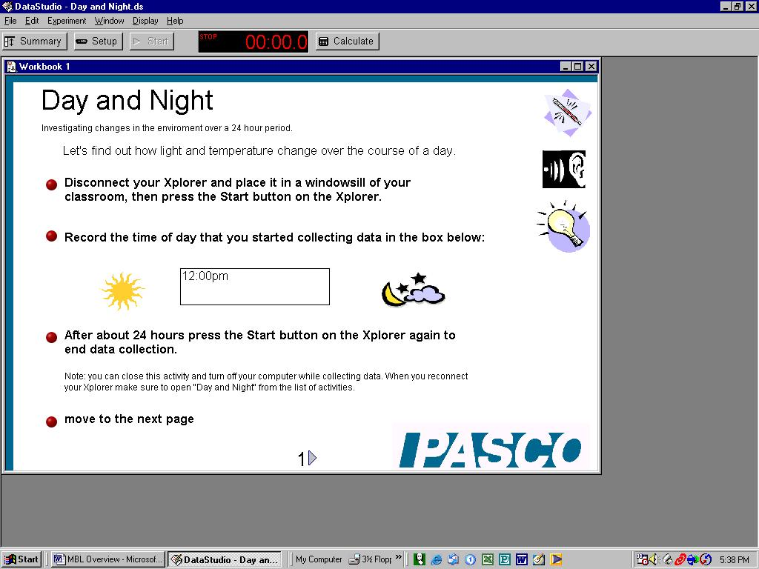

Figure 18. Screen shot of Pasco’s Datastudio. The above screen shows an instructional window that is capable of record student input.

Measuring (input): Yes
Control (output): Sound. I’m not sure if there is output beyond sound, but I think so.
Programmable: through Workbook feature
Triggering: Yes
List of Display Types: Table, Line Graph, Numeric display, bar charts and other representations
Built in Table/Spreadsheet: Yes (table)
Diagramming (drawing tool): Yes
Analog and Digital probes: Yes
Calibration: Automatic or manual
Save a lab: Yes
Analysis: Yes – curve fitting, FFT and more
Multimedia: Pictures at least.
Export: export to Excel.

This software appears relatively flexible and powerful. The Workbook feature allows a lab to be set-up which can show drawings or photos, and ask the student to input data directly into the workbook. Data can be displayed in real time in the Workbook as well. It allows for the creation of a very simplified view of what is needed for a particular experiment. When this feature is in effect, other controls that might complicate things can be hidden from view.

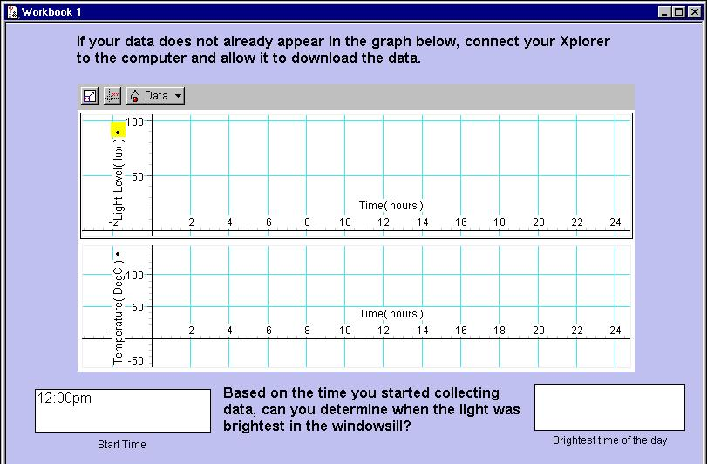

Figure 19. Example of graphical display in Pasco Workbook. When this is displayed, almost all other tools can be hidden to keep the screen clear of distractions.

Summary
Only looking at the light version, and without any probes, this seems to be a relatively elegant piece of software. It has the standard features, some advanced features, and the ability to create experiments that let the workbook developer decide what to show and what not to show.

Vernier
Logger Pro 3 software from Vernier appears to be a powerful tool that can do all the standard MBL things and more.
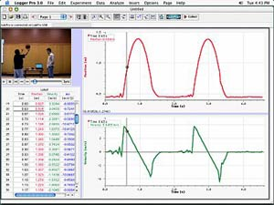
Measuring (input): Yes
Control (output): ?
Programmable: ?
Triggering: Yes
List of Display Types: Table, Line Graph, Numeric display, bar charts and other representations
Built in Table/Spreadsheet: Yes
Diagramming (drawing tool): Yes
Analog and Digital probes: Yes
Calibration: Automatic or manual
Save a lab: Yes
Analysis: Yes – curve fitting, FFT and more
Multimedia: Photos and Video.
Export: export to Excel.
Figure 20. Screen Shot of Logger Pro 3 showing table, 2 graphs and a video.

Summary: I can’t tell from screen shots whether or not features can be turned on/off like Pasco, but this software does have some very nice features. It seems to have a high level of video ability, where data can be synchronized to video of an experiment, etc.

Texas Instruments

TI has GraphLink software, which links TI calculators to a PC (Windows or Mac). There are at least 9 different versions of the software, for 9 versions of TI Calculators.

A newer piece of software called TI Connect appears to streamline the GraphLink software. A single version recognizes all calculators through automatic detection.

TI Connect is used as a conduit to upload applications (Apps) to a TI Calculator, or download data sets. Apps are specific to an experiment. For example, an App could be written to collect specific data for an experiment. Launching the App would then walk a student through the data collection process. The data is then downloaded to a PC through TI Connect for further analysis.

From a cursory analysis, it appears that scripting an App is specific to a particular calculator (Apps are not compatible across calculators.) It does not appear to be an easy thing to do. On the TI site, there is a section called “Activity Exchange,” where teachers can upload activities they have written and successfully used in the classroom. About 20 activities have been uploaded, however none use probes.

Measuring (input): Yes
Control (output): no
Programmable: yes, although difficult.
Triggering: ?
List of Display Types: Table, Line Graph, Numeric display. Not sure about other representations.
Built in Table/Spreadsheet: table
Diagramming (drawing tool): No
Analog and Digital probes: ?
Calibration: Automatic or manual
Save a lab: Yes (App)
Analysis: ?
Multimedia: Not on the calculator
Export: export to Excel (through TI Connect)

