Prompt:
Problem Statement: Vijay and his friend Wei-Lynn are hanging out in the school yard, waiting for the first bell to ring. They decide to race. The pile of backpacks is the finish line. Wei-Lynn will start the race 100 meters West of the pile of backpacks. Because Wei-Lynn holds the eighth grade record for the 100 meter dash, she gives Vijay a 25 meter head start. Vijay also starts West of the pile of backpacks.

INSTRUCTIONS: Draw a picture so that your friend can understand the problem without reading the problem statement. Use the stamp tool to create images for Vijay, Wei-Lynn, a compass, and a backpack.

When drawing, consider the following:
The distances Vijay and Wei-Lynn are from the backpacks
The direction Vijay and Wei-Lynn are with respect to the backpacks
Clearly identifying the components of the drawing, so your friend understands the problem statement
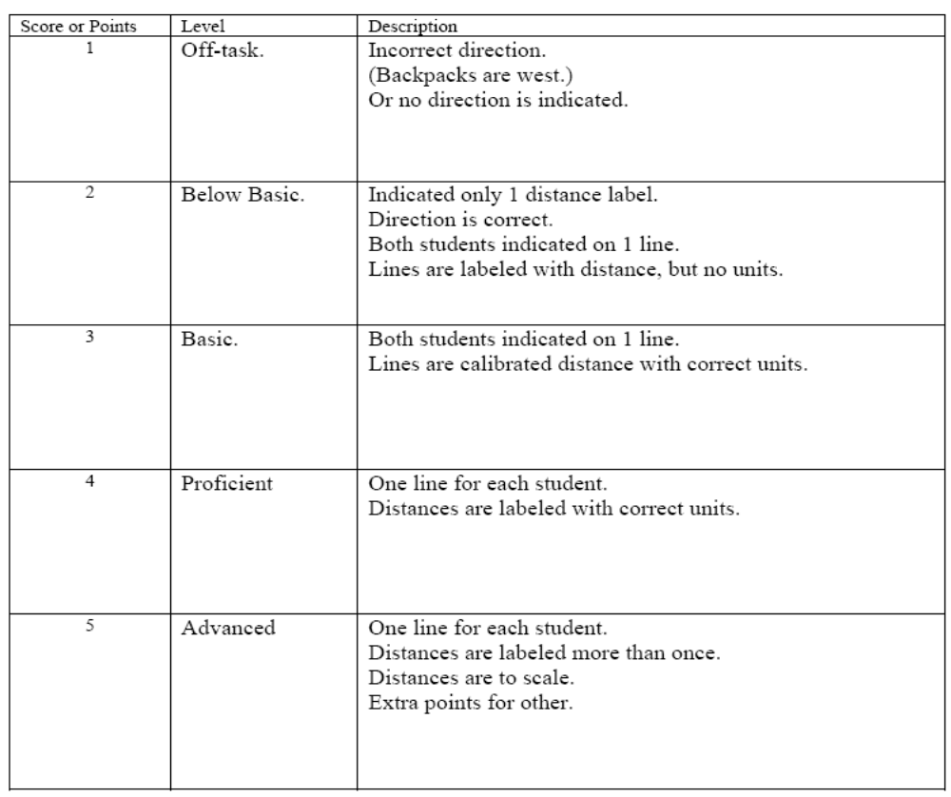

Students Sample Answers:

 | Response
1 | 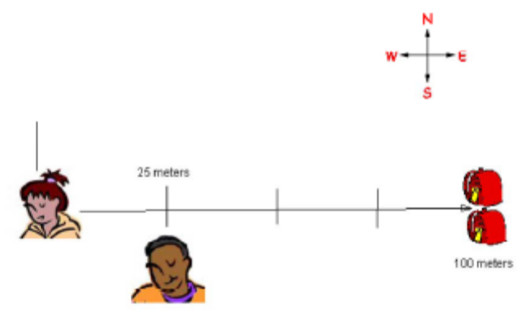
2 | 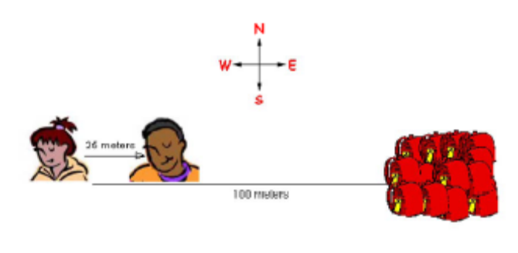
3 | 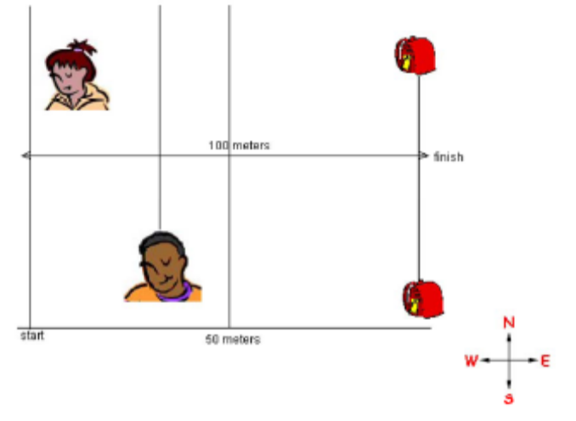
4 | 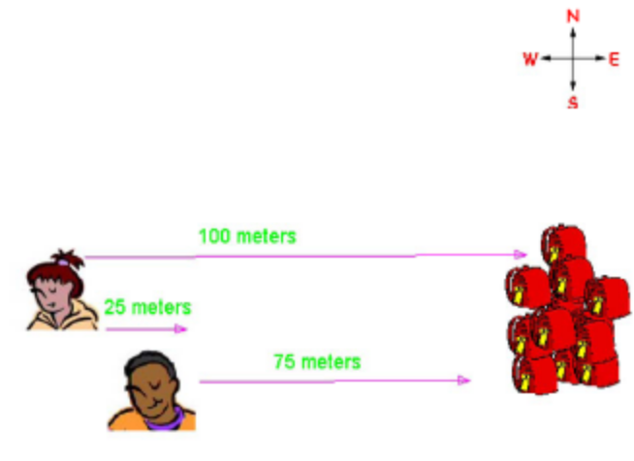
5 | 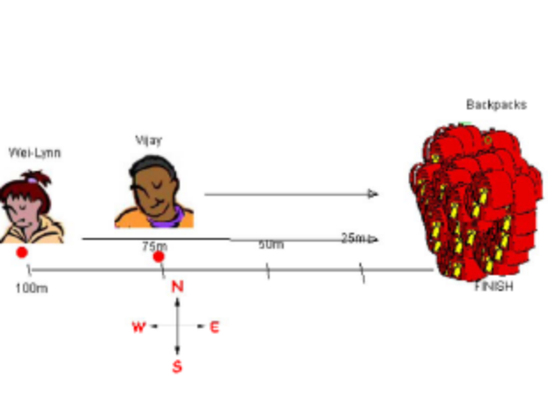
6 | 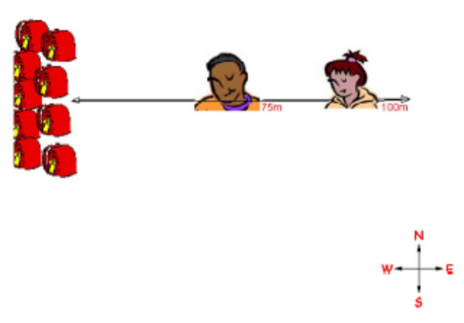
7 | 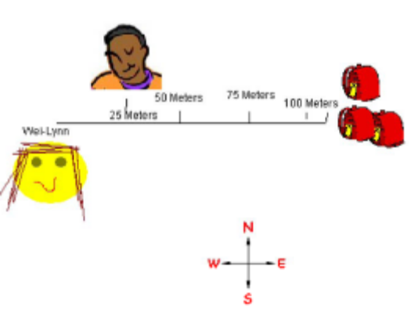
8 | 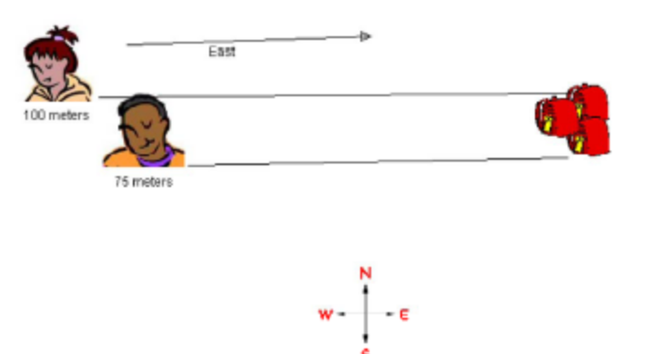
9 | 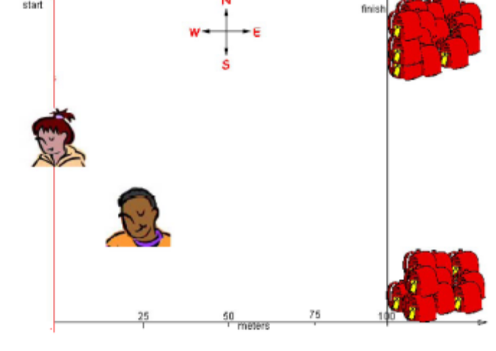
10 | 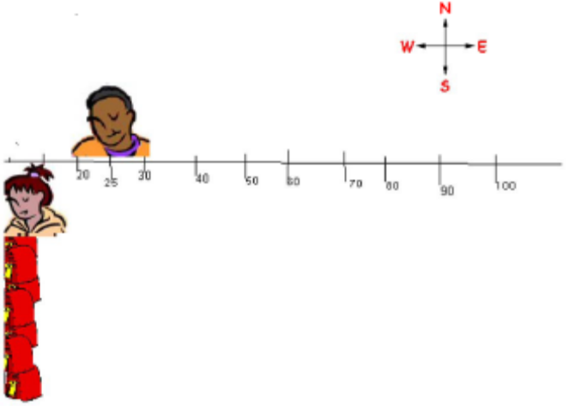
11 | 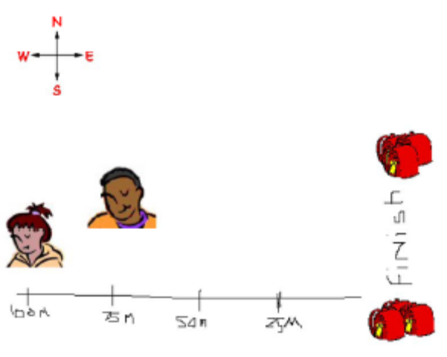
12 | 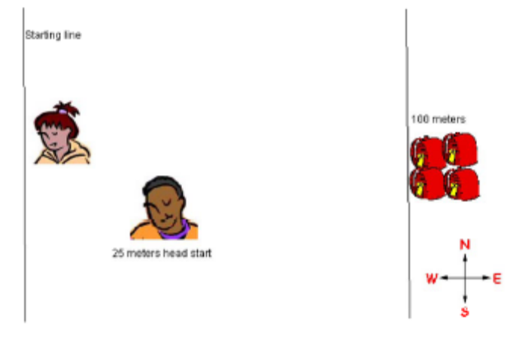
13 | 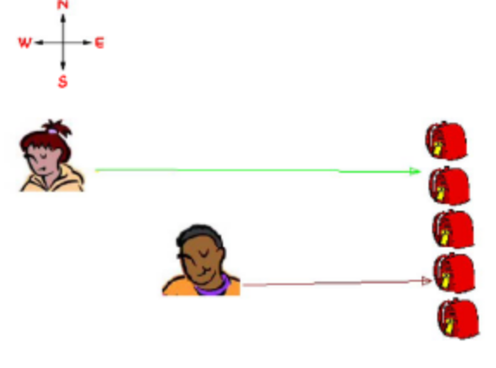
14 | 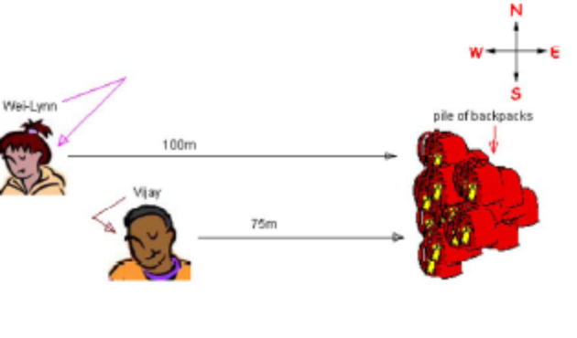
15 | 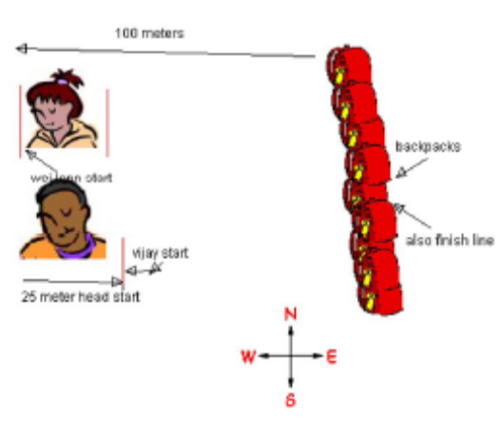

Prompts:
- Record data from the interview which will help you calculate Isabel's velocity. Why do you need this information?
- How would you use this data to calculate Isabel's velocity?
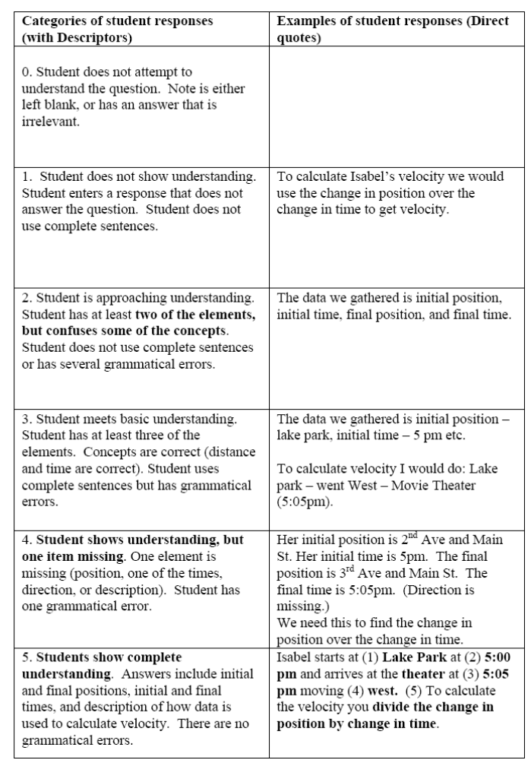

Student Sample Answers:

 | Response
1 | The data we gathered is information about Isabel We need this information because it helps us figure out her velocity.  To calculate Isabel's velocity we would change in osition over change over time.
2 | The data we gathered is:  Initial position: Lake Park  Initial time: 5:00 PM  Final position: Movie Theater  Final time: 5:05 PM  We need this information because is will help us find the speed and velocity she travelled at.  To calculate Isabel's velocity we would divide the distance by time.  3600/300 (300 seconds are in 5 minutes)  12 m/s is the final speed, and the final velocity is 12 m/s West.
3 | The data we gathered is her initial and final position and her initial an final time.  We need this information because it helps us to calculate the velocity and speed.  To calculate Isabel's velocity we would subtract her initial position from her final position and add the direction. Then, we would divide that by her final time minus her initial time.
4 | The data we gathered is that Isabels initial time was lake park.she left at 5:00 and got there at 5:05.  We need this information because all of the information is needed to find the velcity.  To calculate Isabel's velocity we would divide the change in position by the change in time.
5 | The data we gathered is...initial position and time and her final position and time.  We need this information because... we can calculate her velocity wioth it.  To calculate Isabel's velocity we would...divide her change in position by her change in time.
6 | The data we gathered is that she is at the park heading west to the cinema; she started at 5:00 and ended at 5:05.  We need this information because we can infer how long it will take.  To calculate Isabel's velocity we would distince divided by time divided by 60
7 | The data we gathered is the initial time, initial position, final position, and final time. We need this information because so we could figure out the velocity and speed.  To calculate Isabel's velocity we would change in position over change in time.
8 | We need this information because it is important to know. It helps us know who long and it took her to get to the movie theatre from the Lake Park.  It would helo because it tells you how long it took her to get from the Lake Park to the movie theatre .
9 | The data we gathered is she started at 5:00pm at 2nd Avenue and Main Street and she arrived at the Movie Theater at 5:05 pm.  We need this information because to find velocity you need the position, Time she started and the time she finished or the time it was when she got to her destination.  To calculate Isabel's velocity we would divide the distance by time and add a direction.
10 | The data we gathered is that Isabel started trip at Lake Park, the corner of 2nd Avenue and Main Street. left the Lake Park at 5:00 pm ended my trip at Movie Theatre at 3rd Avenue and Main Street  We need this information because...it sets up the hole timeline of her movment.  To calculate Isabel's velocity we would...Final position-initial Position/ Final Time- initial time= Change position / change in time
11 | The data we gathered is initial position, initial time and final time  We need this information because to calculate velocity we need time and displacement.  To calculate Isabel's velocity we would have to, in addition to calculating her time and place, disregarding the fact that the movie she saw was most likely horrible, probably starring Jude Law, also disregarding if she had parental permission or not.
12 | The data we gathered is She started at 2nd Avenue and Main Street at 5 pm going west. She arrived at 3rd Avenue and Main Street at 5:05 pm.  We need this information because we need to find her velocity.  To calculate Isabel's velocity you divide the change in position by change in time.
13 | The data we gathered is that a few people were a couple minutes late and almost didnt get a seat at the theatre. We need this information because I dont know if we really needed this information.  To calculate Isabel's velocity we would say that her last stop was at the park then she went to the theatre.
14 | he data we gathered is started the trip at Lake Park, the corner of 2nd avenue and main street, i left the park at 5:00 PM, and she ended her trip at the movie theatre at 3rd and main streeet, she was running and she arrived at the movie theatre at 5:05 PM. and she was traveling west.  We need this information because to found out how many meters a second she was going and found out her velocity.  To calculate Isabel's velocity we would Divide the distance she went by the time she had to get their, and wich way she went (west.east,north,south).
15 | The data we gathered is useful.  We need this information because it tells us where she was, where she ended, what time she left, what time she ended, and what direction she was traveling.  To calculate Isabel's velocity we would divide the distance by the time and add the direction.

Prompt:
Construct a position versus time graph that shows Shanice's velocity as she moves to meet Wei-Lynn.

INSTRUCTIONS: Select the "grid" background. Use the line tool to construct the graph of Shanice's motion. Use the text tool to create any necessary labels.

When drawing, consider the following:
When choosing the scale for the position axis, calculate the distance between Shanice's and Wei-Lynn's initial positions.
When choosing the scale for the time axis, calculate the time it would take for Shanice to travel from her initial position to the Bus Station.
Remember to label your axes and indicate the scale when you decide on it (by marking the grid lines with numbers).
Remember that velocity is speed in a given direction.
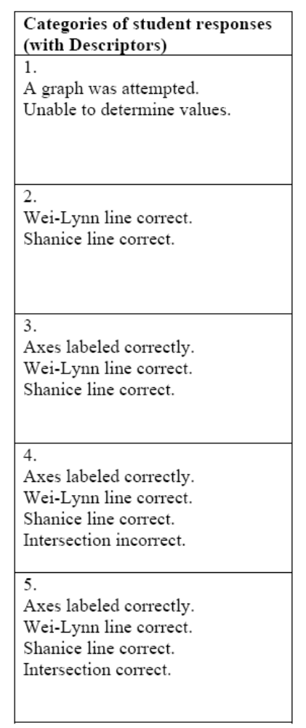
Student Sample Answers:

 | Response
1 | 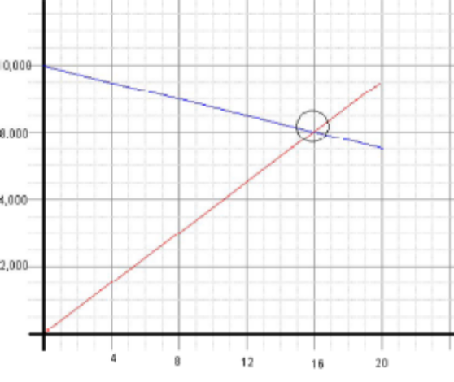
2
3 | 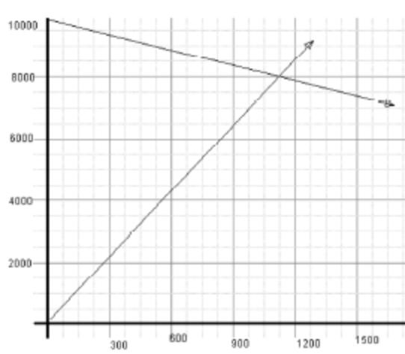
4 | 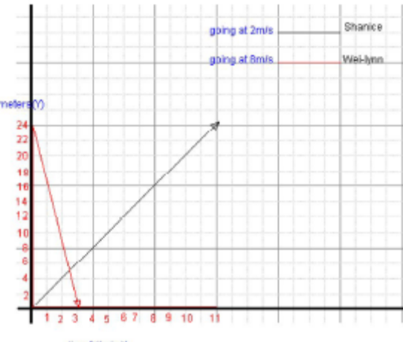
5 | 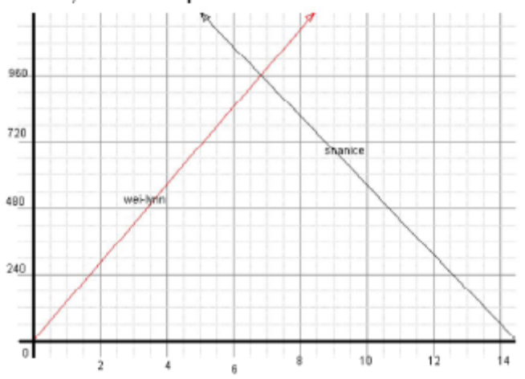
6 | 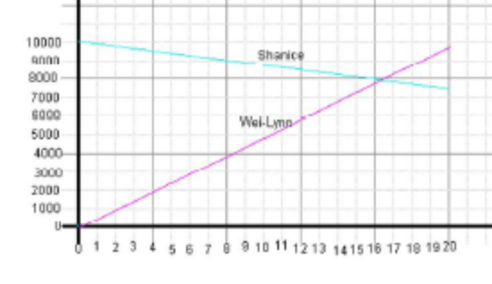
7 | 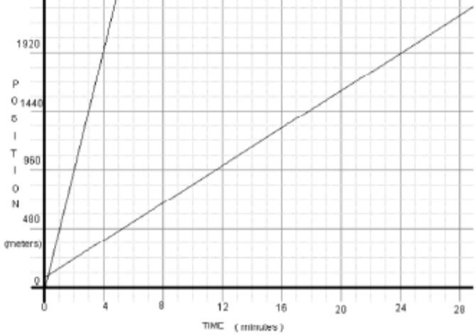
8 | 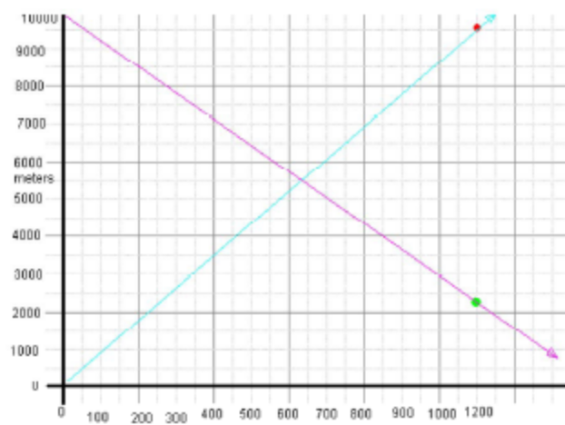
9 | 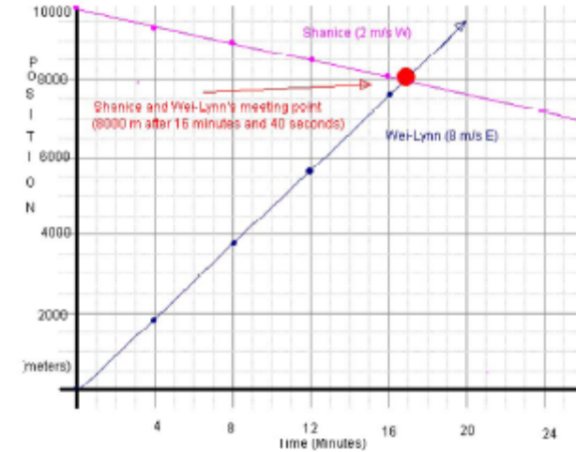
10 | 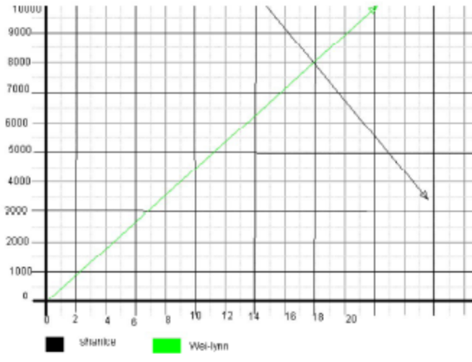
11 | 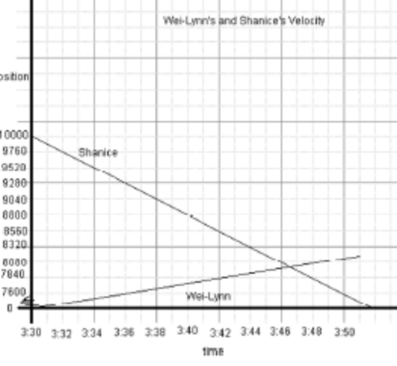
12 | 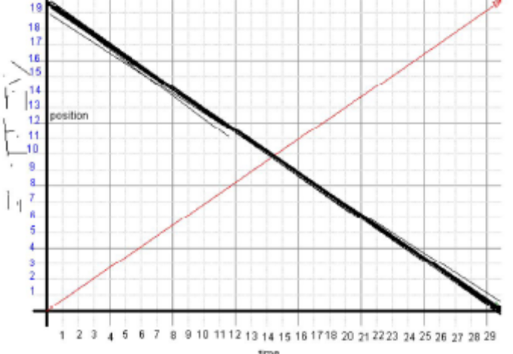
13 | 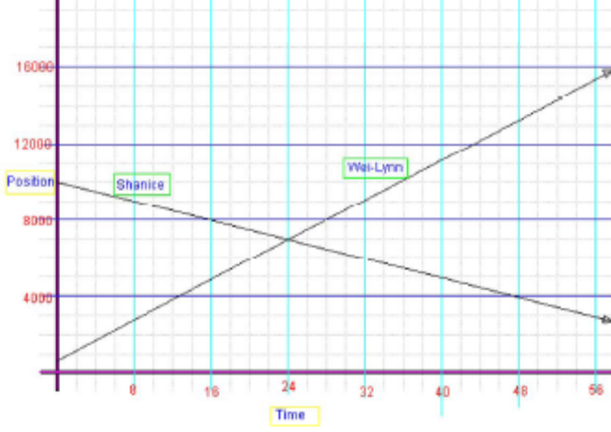
14 | 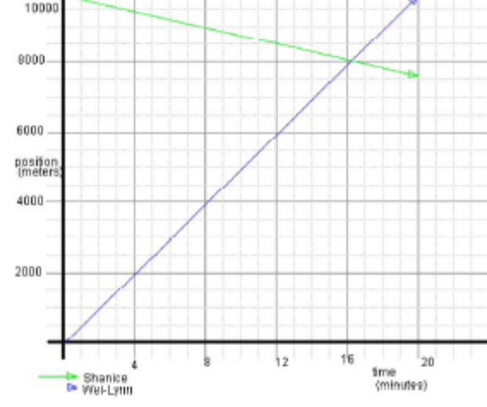
15 | 

